Tab 2016 screenshot

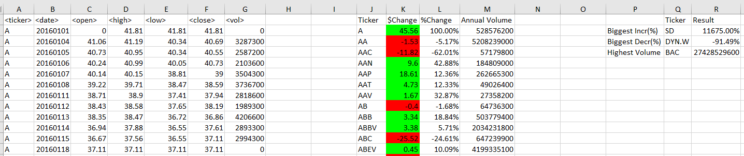

Tab 2015 screenshot

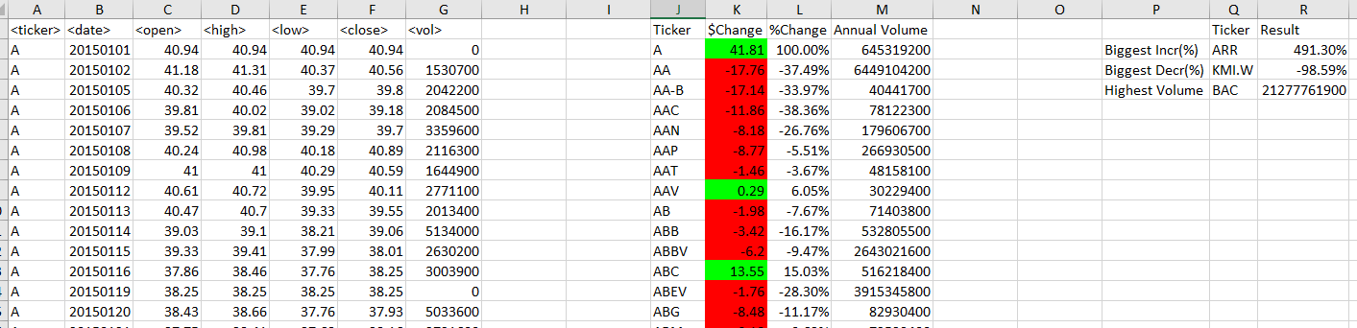

Tab 2014 screenshot

